URBANIA SLIDING GLASS DOOR
NOVATECH PATIO DOORS CANADA INC.
08 32 13 Sliding Aluminum - Framed Glass Doors

PART 1 – GENERAL

  - DISCLAIMOR
NOVATECH PATIO DOORS CANADA INC. reserves the right to change any and all designs without notice. Due to periodic re-certification requirements, results shown may vary slightly.

  - PERFORMANCE CLASS:
The URBANIA sliding door (SD) system was tested to various performance class requirements of AAMA/WDMA/CSA 101/I.S.2/A440-08. These are outlined in Section 1.04

  - TESTING PERFORMANCE STANDARDS:
Except as otherwise indicated, requirements for thermally-broken aluminum doors, terminology and standards of performance and fabrication workmanship are those specified and recommended in AAMA/WDMA/CSA101/I.S.2/ A440-08 (NAFS 11&17).

- Air Infiltration Test: With the door closed and latched, the Air Leakage Resistance test was performed in accordance with Clause 9.3.2 in conjunction with ASTM E283-04, “Standard Test Method for Determining Rate of Air Leakage through Exterior Windows, Curtain Walls, and Doors under Specified Pressure Differences across the Specimen”. Air infiltration testing was performed using a test pressure of 1.57 psf (75 Pa). The air leakage rate was calculated and compared to the allowable air leakage.

- Water Resistance Penetration Test: With the door closed and latched, a four-cycle Water Penetration Resistance test was performed in accordance with Clause 9.3.3 in conjunction with ASTM E547-00 “Standard Test Method for Water Penetration of Exterior Windows, Skylights, Doors, and Curtain Walls by Cyclic Static Air Pressure Difference”. The test was performed using the specified pressure differential and a water spray rate of at least 5.0 US gal/ft² per hour (204 L/m² per hour). Each cycle consisted of five minutes with the pressure applied and one minute with the pressure released, during which the water spray was continuously applied.

- Uniform Load Structural Test: Per A Uniform Load Structural test was conducted in accordance with Clause 9.3.4.3 and ASTM E330-02 "Standard Test Method for Structural Performance of Exterior Windows, Curtain Walls, and Doors by Uniform Static Air Pressure Difference," Procedure A. After a 10 second preload (50% of test load), followed by 1 minute with the pressure released, the sample was subjected to a Uniform Load Structural test using a specified test pressure for a time of 10 seconds. The test was performed in both the positive and negative directions. After the test loads were released, the permanent deflections were recorded as well as the sliding door was inspected for failure or permanent deformation of any part of the sliding door system that would cause any operational malfunction.

  - PHYSICAL PERFORMANCE

Configuration |  | Performance Grade and Class | Air Leakage | Water Penetration Resistance | Design Pressure | Door Details
OX or XO | For door size measuring up to 95 1/2 " × 95 1/2" | LC-PG40 | 0.04 cfm/ft²  (0.21 L/s·m²) | 8.25 psf  (400 Pa) | ±40 psf  (±1920 Pa) | Standard interlock
OX or XO | For door size measuring up to 95 1/2" × 95 1/2" (With reinforcement) | CW-PG55 | 0.04 cfm/ft²  (0.21 L/s·m²) | 8.25 psf  (400 Pa) | ±60 psf  (±2880 Pa) | Standard interlock with meeting reinforcement
OX or XO | For door sizes measuring up to 107" × 95 1/2"(With reinforcement) | CW-PG40 | 0.05 cfm/ft²  (0.27 L/s·m²) | 9.0 psf  (440 Pa) | ±40 psf  (±1920 Pa) | Standard interlock with meeting reinforcement
OX or XO | For door sizes measuring up to 102’’ x 108’’(With reinforcement)  1 or 2 Topelite | LC-PG35 | 0.10 cfm/ft²  (0.5 L/s·m²) | 9.19 psf  (440 Pa) | ±35.09 psf  (±1680 Pa) | Standard interlock with meeting reinforcement
OX or XO | For door sizes measuring up to 107" × 108"(With reinforcement)  1 or 2 Toplite | LC-PG25 | 0.08 cfm/ft²  (0.39 L/s·m²) | 9.19 psf  (440 Pa) | ±25.06 psf  (±1200 Pa) | Standard interlock with meeting reinforcement
OX or XO | For door sizes measuring up to 179" × 95 1/2"(With reinforcement)  1 Sidelite | CW-PG40 | 0.07 cfm/ft²  (0.35 L/s·m²) | 9.19 psf  (440 Pa) | ±40 psf  (±1920 Pa) | Standard interlock with meeting reinforcement
OX or XO | For door sizes measuring up to 192" × 108"(With reinforcement)  2 Sidelite | LC-PG45 | 0.03 cfm/ft²  (0.17 L/s·m²) | 6.89 psf  (330 Pa) | ±50.13 psf  (±2400 Pa) | Standard interlock with meeting reinforcement
OX or XO | For door sizes measuring up to 192" × 108"(With reinforcement)  2 Sidelite | CW-PG35 | 0.03 cfm/ft²  (0.17 L/s·m²) | 6.89 psf  (330 Pa) | ±35.09 psf  (±1680 Pa) | Standard interlock with meeting reinforcement
OX or XO | For door sizes measuring up to 179 1/8" × 108"(With reinforcement)  1 Sidelite / 2 Topelite | LC-PG25 | 0.05 cfm/ft²  (0.26 L/s·m²) | 9.19 psf  (440 Pa) | ±25.06 psf  (±1200 Pa) | Standard interlock with meeting reinforcement
OXXO | For door sizes measuring up to 189 3/8" × 108"(With reinforcement) | LC-PG40 | 0.08 cfm/ft²  (0.43 L/s·m²) | 6.89 psf  (330 Pa) | ±40.10 psf  (±1920 Pa) | Standard interlock with meeting and handle reinforcement
Fixed Frame | For door sizes measuring up to 72’’ x 95 ½’’ | CW-PG50 | 0.04 cfm/ft²  (0.20 L/s·m²) | 10.65 psf  (510 Pa) | ±50 psf  (±2400 Pa) | Standard fixed frame
Fixed Frame | For door sizes measuring up to 72’’ x 130’’ | CW-PG45 | 0.03 cfm/ft²  (0.15 L/s·m²) | 10.65 psf  (510 Pa) | ±45 psf  (±2160 Pa) | Standard fixed frame

  - ENERGY PERFORMANCE
Glass Package | U-value*  (Btu/h·ft.²·°F) | SHGC*
LowE 180ESC (3mm) (S#3) | 0.33 Btu/h·ft.²·°F  1.87 W/m²K | 0.57 w/o grids  0.44 w/ grids
LowE 70/36 (3mm) (S#2) | 0.32 Btu/h·ft.²·°F  1.82 W/m²K | 0.30 w/o grids  0.24 w/ grids
LowE 62/27 (3mm) (S#2) | 0.31 Btu/h·ft.²·°F  1.76 W/m²K | 0.20 w/o grids  0.16 w/ grids
LowE 180ESC (4mm) (S#3 | 0.33 Btu/h·ft.²·°F  1.87 W/m²K | 0.56 w/o grids  0.43 w/ grids
LowE 70/36 (4mm) (S#2) | 0.31 Btu/h·ft.²·°F  1.76 W/m²K | 0.30 w/o grids  0.24 w/ grids
LowE 62/27 (4mm) (S#2) | 0.31 Btu/h·ft.²·°F  1.76 W/m²K | 0.20 w/o grids  0.16 w/ grids
* U-factor of the sliding door system was determined using the simulation procedure specified in NFRC 100 and the SHGC was determined using simulation procedures specified in NFRC 200. The simulation was conducted to NFRC 100 and NFRC 200 using specialized computer simulation software that was developed by the Lawrence Berkeley National Laboratory and is consistent with the ISO 15099 standard.

  - ACOUSTICAL PERFORMANCE
Glass Package | STC
4mm Tempered – 4mm Tempered | 29
4mm Tempered – 4mm Tempered  (1 -¼’’) | 31
6mm Tempered – 6mm Tempered | 32
4mm Tempered – 6mm Tempered  (1-¼’’) | 35
4mm Tempered – 8mm Laminated | 37

  - WARRANTY
Standard Product Warranty: Refer to the applicable Novatech Patio Doors Warranty.

  - DOOR FEATURES
- Available Configurations
- OX, XO (as viewed from exterior)
- OXXO (as viewed from exterior)
- Coordinated transoms & sidelites are available

- Framing System
- Mechanically fastened thermally-broken aluminum main frame (sill, jambs and header)
- Thermal break is made of polyamid and PVC
- Two-colour system allows for different colour scheme on interior and exterior
- Two standard thicknesses frame: 6’’ and 7-¼’’ flush
- An optional 2’’ extension is available to achieve thicknesses of 8’’ and 9-¼’’
- 4-9/16" jamb depth (behind nail fin)
- 6-9/16’’ jamb depth (behind nail fin)
- Nailing fin available

- Panel System
- Mechanically-fastened, thermally-broken aluminum panel members
- Thermal break is made of polyamid and PVC
- Optional reinforcements available depending on design pressure requirements

- Frame/Panel Material Properties
- Door finishes available include:
  - Anodized finish (meets AAMA 611)
  - Duracron® (meets AAMA 2603)
  - Acrynar (meets AAMA 2604)
  - Duranar® (meets AAMA 2605)
  - Powder coat painted profiles (meets AAMA 2604/2605)

- 4.) Type of hardware
- Heavy-duty tandem wheel, adjustable roller system
- Double point mortise / Double point keeper
- Standard Hardware colors available (White, Black or Satin Chrome)

- Glazing
- 1” and 1 1/8’’ glazing beads for double and triple IGU
- Low-E w/argon gas
- Various glazing, tinting and thickness options available (Contact Novatech office)

- Muntin choices
- Internal grills

- Screen choices
- Fiberglass screen mesh (standard)
- Aluminum screen mesh (optional)
- Heavy duty ‘’Robusto’’ screen (optional)

PART 2 – PRODUCTS

  - MANUFACTURER
Novatech Patio Doors Canada Inc.
100, 181e Rue
Beauceville
G5X 2T1
418-774-2949

  - MATERIAL
- Aluminum Extrusions: All extruded sections shall be of 6063-T5 aluminum alloy.

- Hardware: Hardware having component parts which are exposed shall be of aluminum, stainless steel, or other non-corrosive materials compatible with aluminum.

- Weather-stripping: Double weather-stripping using woven pile with polypropylene fin center.

- Glass: All glazing shall be glazed at the factory as follows:

    - All units are constructed to an overall minimum thickness of 1" or 1 1/8’’ with two or three lites of tempered glass (4mm, 5mm or 6mm as size and loading requires).
    - Glazing Options: Optional glazing such as triple-glazing, tinted, laminated, reflective, low-E, argon-filled and others are available upon request.

- Screens: Screens frames are manufactured from extruded aluminum.

  - FABRICATION
- Sliding Glass Door Members: All sash sections are constructed from extruded aluminum extrusions and PVC.

- All aluminum main frame and panel extrusions have a nominal wall thickness of 0.059" (1.50mm).
- Depth of frame and panel not less than 6".

- Sash Construction: The operating panels are constructed from thermally-broken, extruded aluminum and PVC. The vertical interlock stiles may be additionally reinforced with 10 Ga galvanized steel stiffeners.

- Assembly: The vinyl/aluminum sliding glass door is assembled in a secure and workmanlike manner to perform as hereinafter specified. All corners of the main frame and panel are mechanically fastened.

- Glazing: The sealed unit uses glazing beads

- Rollers and Roller Assembly: Moveable panels shall be fitted with rollers and roller assemblies. Rollers and roller assemblies shall be designed to provide easy movement and to adequately support the panel during extended usage without deforming or developing flat spots.

PART 3 – EXECUTION

  - INSTALLATION
- Comply with manufacturer’s specifications and recommendations for installation of sliding door units.

- Set units plumb, level and true to line, without warp or rack of frames or panels. Anchor securely in place. Doors must be securely blocked and fastened.

- Low-expanding window/door spray foam insulation between frames of new sliding door and construction to remain, or between frames and new blocking as applicable.

- Set sill members and other members in bed of compound, or with joint filler or gaskets, to provide weathertight construction. Seal units following installation and as required to provide a weathertight system.

- Fasteners: PVC, Aluminum, stainless steel, or other materials warranted by manufacturer to be non- corrosive and compatible with sliding door members, hardware and other components of the sliding door.

  - OPERATION AND MAINTENANCE
- Adjust operating panel and hardware to provide tight fit at contact points and at weather-stripping. Adjust also for smooth operation and a weathertight closure.

- Clean aluminum surfaces promptly after installation of sliding door, exercising care to avoid damage to the finish. Remove excess sealant compound, dirt and other substances.

- For frame and panel cleaning, use a common window cleaner or mild detergent solution with a regular cloth. After cleaning, be sure to thoroughly rinse all surfaces with clean water to remove any detergent residue.

- Clean glass promptly after installation of sliding door. Remove glazing and sealant compound, dirt and other substances.
- Use a common glass cleaner with a lint-free cloth or chamois.
- Do Not Use:
- Caustic or abrasive cleaner or any silicon-based solvents on the frame or panel surfaces, as they may damage or discolor the finish
- Petroleum-based lubricants as they may discolor the finish
- Insecticides (bug spray) on or near window surface. Contact of insecticides with the finish could damage or discolor the door surface.

- Initiate all protection and other precautions required to ensure that door units will be without damage or deterioration at time of acceptance.

For additional information, please contact your sales representative.

URBANIA Door (standard) Cross-section Drawings

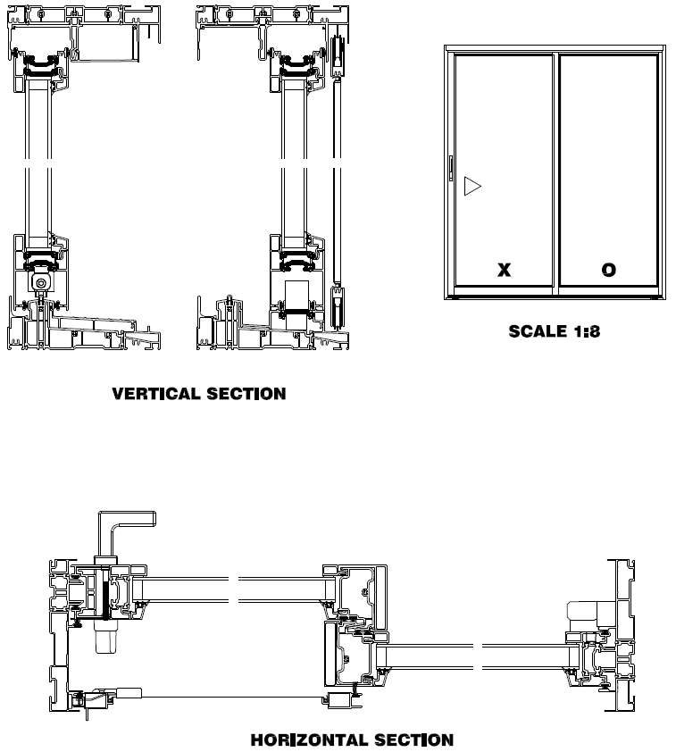
URBANIA Door (Reinforced) Cross-section Drawings

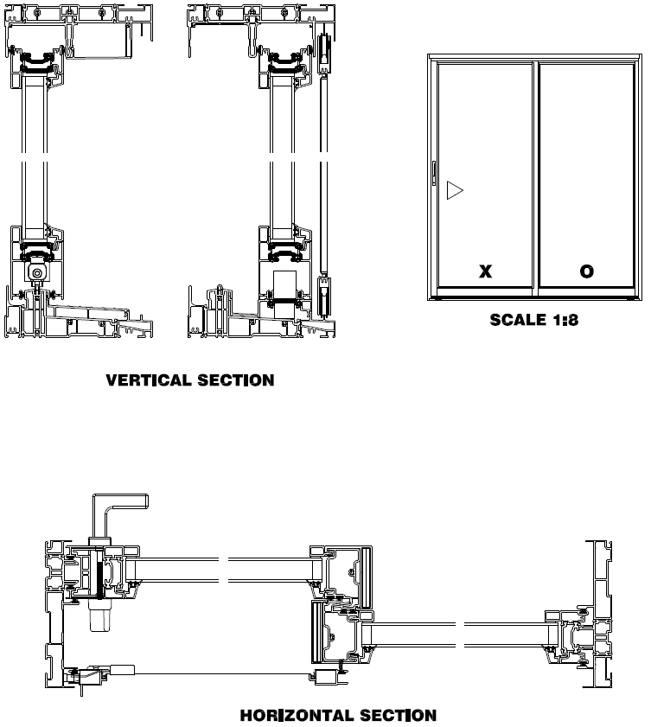

URBANIA Door (standard) Cross-section Drawings

