GENTEK
REGENCY 400 SERIES

Casement + Awning
Windows

Technical Specifications
and Cross-Sectional
Details

Table of Contents
CONSTRUCTIONS SPECIFICATIONS - SECTION 08 54 00 2
PART 1 GENERAL 2
1.1. SECTION INCLUDES 2
1.2. REFERENCES 2
1.3. SUBMITTALS 2
1.4. QUALITY ASSURANCE 3
1.5. STORAGE AND HANDLING 3
1.6. WARRANTY 3
PART 2 PRODUCTS 3
2.1. MANUFACTURED UNITS 3
2.2. FRAME DESCRIPTION 3
2.3. OPTIONAL HARDWARE 5
2.4. WEATHER STRIP 5
2.5. JAMB EXTENSION 5
2.6. INSECT SCREEN 5
2.7. GRILLES-BETWEEN-THE–GLASS 5
2.8. SIMULATED DIVIDED LITES (SDL) 5
2.9. ACCESSORIES AND TRIM 5
PART 3 EXECUTION 6
3.1. EXAMINATION 6
3.2. INSTALLATION 6
3.3. FIELD QUALITY CONTROL 6
3.4. CLEANING 6
3.5. PROTECTING INSTALLED CONSTRUCTION 6
WINDOW TYPE AND CLASSIFICATIONS 7
ENERGY STAR 8
THERMAL RESULTS 10
CROSS SECTION DETAILS 12
CASEMENT WINDOW - OPERATING 12
AWNING WINDOW 14
MULLING ASSEMBLY - COMPOSITE 16

CONSTRUCTIONS SPECIFICATIONS - SECTION 08 54 00

PART 1 GENERAL

SECTION INCLUDES
- Regency 400 Casement / Awning Window complete with hardware, glazing, mulling options, weather strip, insect screen, grilles-between-the-glass, jamb extension, exterior brickmould trims, exterior sill extension and standard or specified anchors, trim and attachments

REFERENCES
- ASTM International (ASTM):
      - American Society for Testing and Materials (ASTM):
- C1036: Standard Specification for Flat Glass.
- E 283: Standard Test Method for Rate of Air Leakage through Exterior Windows, Curtain Walls and Doors.
- E 330: Standard Test Method for Structural Performance of Exterior Windows, Curtain Walls, and Door by Uniform Static Air Pressure Difference.
- E 547: Standard Test Method for Water Penetration of Exterior Windows, Curtain Walls, and Doors by Cyclic Static Air Pressure Differential.
- E 2190: Standard Specification for Insulating Glass Unit Performance Evaluation.
- F 2090-10: Standard Specification for Window Fall Prevention Devices with Emergency Escape (Egress) Release Mechanisms.

- American Architectural Manufacturer’s Association/Window and Door Manufacturer’s Association/Canadian Standards Association (AAMA/WDMA/CSA): (use appropriate specifications depending on certification for each product type).
- AAMA/WDMA/CSA 101/I.S.2/A440-08/11,S11-09, S1-17: North American Fenestration Standard/Specification for windows, doors, and skylights.
- AAMA 450-10: Voluntary Performance Rating Method for Mulled Fenestration Assemblies
- Window and Door Manufacturer’s Association (WDMA): Keystone Certification Program
- Insulating Glass Manufacturer’s Alliance/Insulating Glass Certification Council (IGMA/IGCC).
- National Fenestration Rating Council (NFRC):
- 101: Procedures for Determining Fenestration Product Thermal Properties.
- 200: Procedure for Determining Solar Heat Gain Coefficients at Normal Incidence

SUBMITTALS
- Shop Drawings: Submit shop drawings.
- Samples: Specified performance and design requirements.
- Quality Control Submittals: Certificates: Submit manufacturer’s certification indicating compliance with specified performance and design requirement

QUALITY ASSURANCE
- Requirements: consult local code for NBC [National Building Code] adoption year and pertinent revisions for information on:
- Egress, emergency escape and rescue requirements.
- Basement window requirements.
- Windows fall prevention and/or window opening control device requirements.

STORAGE AND HANDLING
- Applicable frames and mulled units will include additional bracing to maintain squareness and rigidity during shipment.
- Store window units in an upright position in a clean and dry storage area above ground to protect from weather.

WARRANTY
The following limited warranty is subject to conditions and exclusions. There are certain conditions or applications over which Gentek has no control. Defect or problems as a result of such conditions or applications are not the responsibility of GENTEK. For a more complete description of the GENTEK limited warranty, refer to the complete and current warranty information available by request.

Clear insulating glass with SuperSpacer© foam spacers is warranted against seal failure caused by manufacturing defects and resulting in visible obstruction through the glass for twent-five (25) years from the original date of purchase. Glass is warranted against stress cracks caused by manufacturing defects from twelve (12) months from the original date of purchase.

Hardware and other non-glass components are warranted to be free from manufacturing defects for ten (10) years from the original date of purchase.

PART 2 PRODUCTS

MANUFACTURED UNITS
- Description: Regency 400 Casement / Awning units as manufactured by GENTEK Group of Companies
  - London, Ontario, Canada

FRAME DESCRIPTION
- Frame:
- Frame – Vinyl: Members shall be manufactured from 0.079” [2mm] extruded unplasticized polyvinylchloride (uPVC). Frame corners shall be fusion welded and cleaned.
- Frame Depth – Vinyl: Frame shall have standard jamb depth of 4 1/2” [114mm]
- Interior and exterior frame expander accessory are factory installed.
- Interior and exterior fabricated frame expander components, including head-jamb, sill and both jamb components.

- SASH DESCRIPTION
- Sash: Unplasticized polyvinylchloride (uPVC). Sash corners shall be fusion welded and cleaned.
- Sash Profile: Vinyl: Members shall be manufactured from 0.079” [2mm]

- GLAZING
- Select quality complying with ASTM C 1036. Insulating glass SIGMA/IGCC when tested in accordance with ASTM E 2190. STC/OITC ratings are tested to the stated performance level in accordance with ASTM E 90-09.
- Glazing Method: 1 3/16” (30mm) insulating glass for Triple glazing, 7/8” for Dual.
- Glass Type: Vitro Sungate 400, SB60. Cardinal CS73.
- Glass Type Options: Obscure Glass, Rain Glass, Bronze Tint, Gray Tint.
- Glazing Seal: Pressure gasket at exterior; interior has glazing boot inserted.
- Perimeter Spacer: Default color is mill finish (stainless).
- Glazing Option: STC/OITC upgrade.

- MULLING
- Directional mull limits: 6 wide by 1 unit high; Rough Opening not to exceed 114” x 84” (2896mm x 2134mm).
- Directional mull limits: 5 units wide by 5 units high: Rough Opening not to exceed 96” x 84” (2438mm x 2134mm).

- FINISH
- Exterior Vinyl Colour: Standard white.
- Exterior Painted Colour: Black plus 19 other Gentek standard colours. Custom colour available upon request to a GENTEK representative,

- HARDWARE
- Lock: Multipoint locking mechanism is actuated from a single point of operation. The lock mechanism is concealed with only the actuator handle and escutcheon being visible to the interior.
- Hinges: Concealed stainless steel track and injection molded shoe.
- Handle: Die cast detachable folding handle.
- Roto-gear Operator: Stainless hinge arm and housing mechanism.
- Snubber: Pulls the sash tight to the frame and provides engagement to keep the sash in place under structural loads.
- Colour: Applies to handle and locking hardware:
- Standard Color: White; Black is available with painted interior option for casements and awnings.

OPTIONAL HARDWARE
- Coastal hardware (Stainless Steel) is available: Factory applied.
- Casement Window Opening Control Device: Factory applied.
- Awning Window Opening Control Device: Factory applied.

WEATHER STRIP
- Primary weather strip is an extruded bulb attached to all four sides of the sash and the frame provides seal between sash and frame. Integrated t-slots are available for replacement weather-strippings.
- Secondary weather strip is a fin-seale on the exterior portion of the sash and provides a secondary seal between sash and frame.
- Standard weather strip colour: White. Black standard with casement and awning painted colours and optional for non painted casement and awnings.

JAMB EXTENSION
- Standard: factory-installed jamb extension; various sizes and finishes available.

INSECT SCREEN
- Tested to ASTM E-1748-95(09).
- Factory-installed screen; screen mesh: charcoal fiberglass.
- Aluminum frame finish: Matches interior colour options.

GRILLES-BETWEEN-THE–GLASS
- Manufactured from aluminum profile placed between the two panes of glass.
- Interior Colours: Various colours, including split finishes are available.
- Exterior Colours: Various colours, including split finishes are available.
- Profiles: Various profile shapes are available, contact an GENTEK representative.
- Pattern: Various patterns are available, contact an GENTEK representative. .

SIMULATED DIVIDED LITES (SDL)
- Size: ¾” (19mm) wide, 2” (50mm) wide with internal grid spacer bar.
- Colours: Various standard and custom colours available, contact an GENTEK representative.

ACCESSORIES AND TRIM
- Exterior Casing: Offset brickmould available in standard and custom colors.
- Installation Accessories: Factory-installed aluminum nailing fin at head, sill and side jambs.
- Installation brackets
- Mullion kit: standard mullion kit for filed assembly of related units available. Kit includes: Instruction, interior and exterior mull covers and brackets.

PART 3 EXECUTION

EXAMINATION
- Verification of Condition: Before installation, verify openings are plumb, square and of proper dimensions. Report frame defects or unsuitable conditions to the General Contractor and/or GENTEK directly before proceeding. Damages or defects must be reported within 72 hours of receipt of finished goods.
- Acceptance of Condition: Beginning installation or no notification within the 72 hours confirms acceptance of existing conditions.

INSTALLATION
- Assemble and install window/door unit(s) according to manufacturer’s instruction and reviewed shop drawing.
- Install sealant and related backing materials at perimeter of unit or assembly in accordance to reviewed shop drawings.
- Install accessory items as required.

FIELD QUALITY CONTROL
- Remove visible labels and adhesive residue according to manufacturers’ instruction
- Unless otherwise specified, water penetration resistance testing shall be conducted per AAMA 502 and ASTM E1105 at 2/3 of the fenestration products design pressure (DP) rating. Water penetration shall be defined in accordance with the test method(s) applied.

CLEANING
- Remove visible labels and adhesive residue according to manufacturer’s instruction.
- Leave windows and glass in a clean condition.

PROTECTING INSTALLED CONSTRUCTION
- Protecting windows from damage by chemicals, solvents, paint or other construction operations that may cause damage.

END OF SECTION

WINDOW TYPE AND CLASSIFICATIONS
Design Performance Classifications
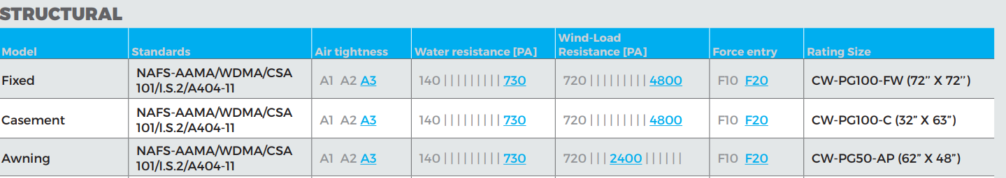

Screen Testing Performance
Product | Canadian Supplement  A440-S01-09
Casement | ASTM E1748-95(09) | Passed
Awning | ASTM E1748-95(09 | Passed

ENERGY STAR
ENERGY STAR® Program - Canada
This technical specification determines how residential windows, doors, and skylights sold in Canada are certified for the ENERGY
STAR® program. This specification is issued by Natural Resources Canada (NRCan). NRCan has been authorized by the U.S. Environmental Protection Agency (EPA) to promote and administer the ENERGY STAR name and symbol in Canada. A product must meet this specification in order to be promoted as ENERGY STAR certified in Canada by its manufacturer or authorized agent. Manufacturers must also sign a Fenestration Administrative Arrangement with NRCan.
Performance metrics
U-Factor: The heat transfer per time per area and per degree of temperature difference in W/m2∙K (Btu/h ft2∙˚F). The U-factor multiplied by the interior-exterior temperature difference and by the projected fenestration product area yields the total heat transfer
through the fenestration product due to conduction, convection, and long-wave infra-red radiation. A U-factor in Btu/h ft2·°F multiplied by 5.678263 converts the value to W/m2·K. The U-factor in Btu/h ft2·°F shall conform with Table 1 before the conversion to W/m2·K.
Solar heat gain coefficient (SHGC): The ratio of the solar heat gain entering the space through the fenestration product to the incident solar radiation.
Air leakage: the flow of air that passes through fenestration products in L/s/m2. Air leakage infiltration is the flow of air into the building envelope and exfiltration is the flow of air out of the building envelope. An air leakage in cfm/ft2 multiplied by 5.08 converts the value to L/s/m2. The air leakage value in cfm/ft2 shall conform with Table 1 before the conversion to L/s/m2.
Energy rating (ER): a unitless value derived from a formula that balances heat loss (U-factor), air leakage loss and potential passive solar gain of a fenestration product. The ER is applied to fenestration systems intended to be installed in a vertical orientation in low-rise residential buildings. The simplified ER equation is as follows:
ER = (57.76 × SHGCw) – (21.90 × Uw) – (1.97 × L75) + 40 where
- SHGCw = fenestration system solar heat gain coefficient
- Uw = fenestration system U-factor (W/m2)
- L75 = fenestration system air leakage rate at a pressure difference of 75 Pa, established in accordance with AAMA/WDMA/CSA 101/I.S.2/A440 (North American Fenestration Standard) in L/s•m2. The L75 shall be the average of the infiltration and exfiltration measurements.

A complete explanation of the ER equation may be found in the CSA A440.2 Standard.

U-factor Criteria for Residential Windows and Doors
Product | Maximum U-factor W/m2∙K | Maximum U-factor Btu/h∙ft2◦F
Windows and Doors | 1.22 | 0.21

Alternate ER Criteria for Residential Windows and Doors
Product | Minimum ER (unitless)
Windows and Doors | 34

U-factor Criteria for Unit Skylights
Product | Maximum U-factor W/m2∙K | Maximum U-factor Btu/h∙ft2◦F
Skylights | 2.29 | 0.4

THERMAL RESULTS
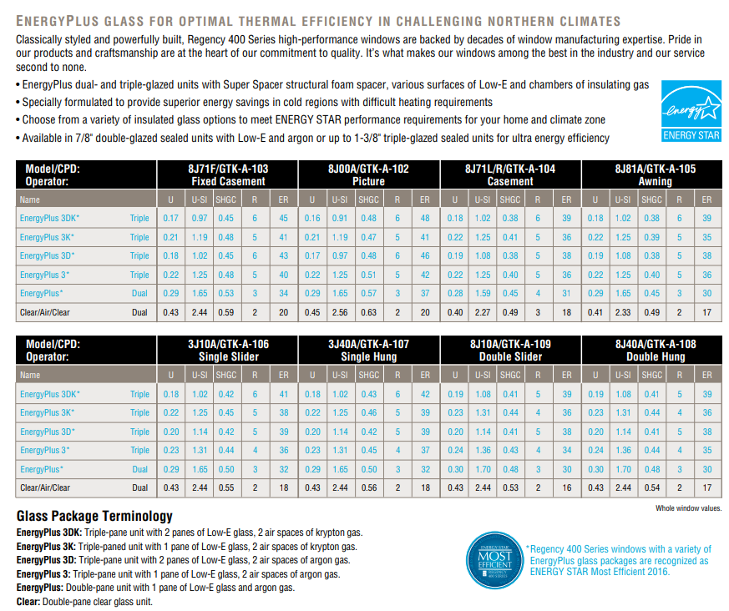
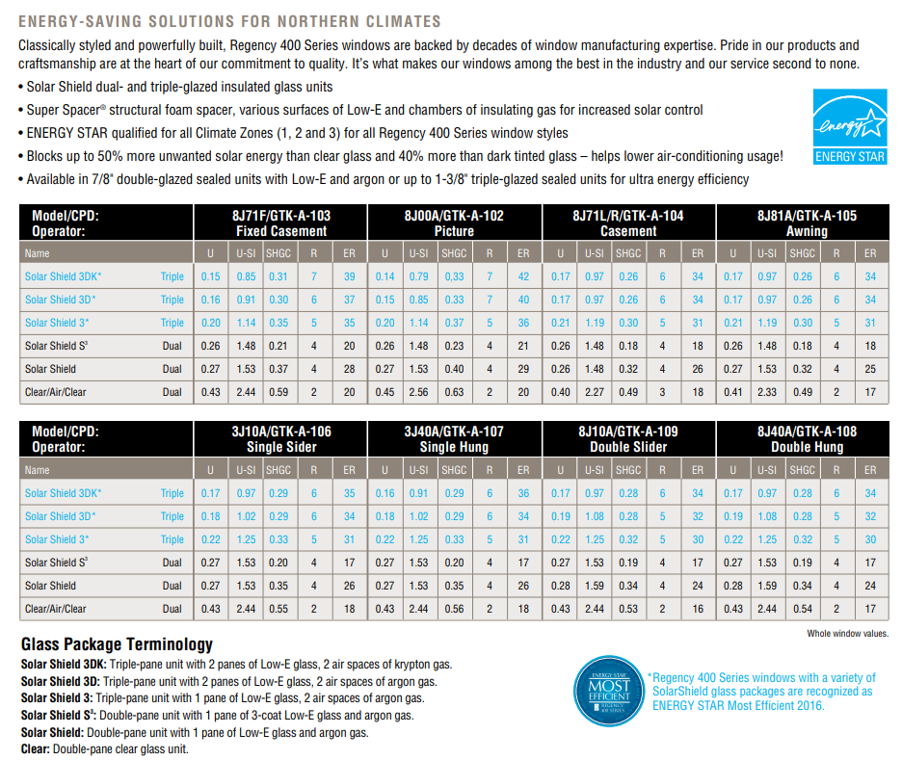

CROSS SECTION DETAILS

CASEMENT WINDOW - OPERATING
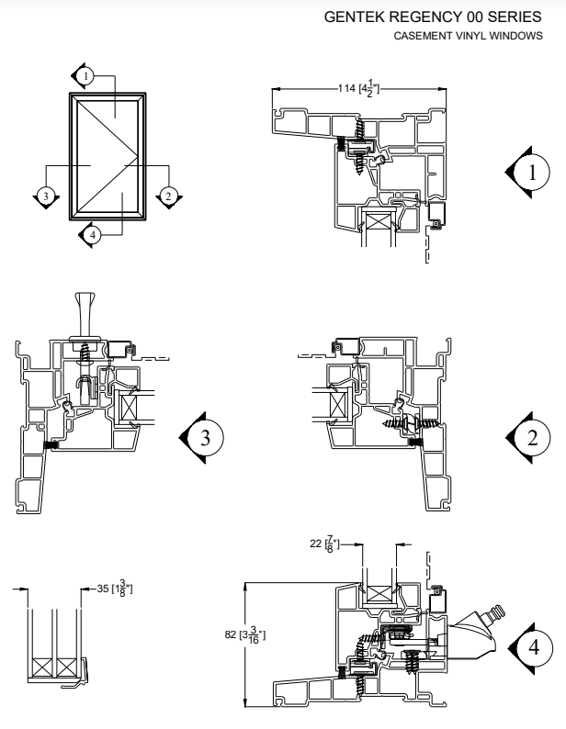
CASEMENT WINDOW – FIXED
CASEMENT WINDOW – FIXED

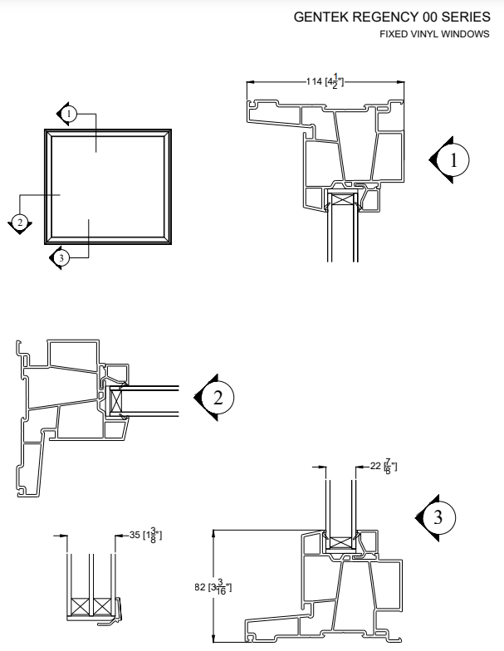

AWNING WINDOW
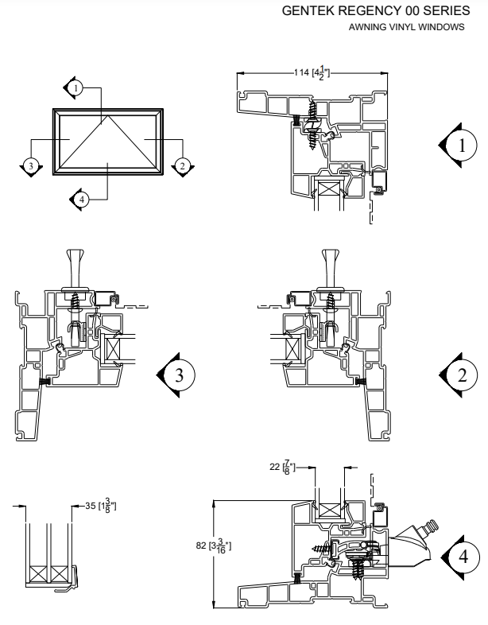

FIXED PANORAMIC WINDOW

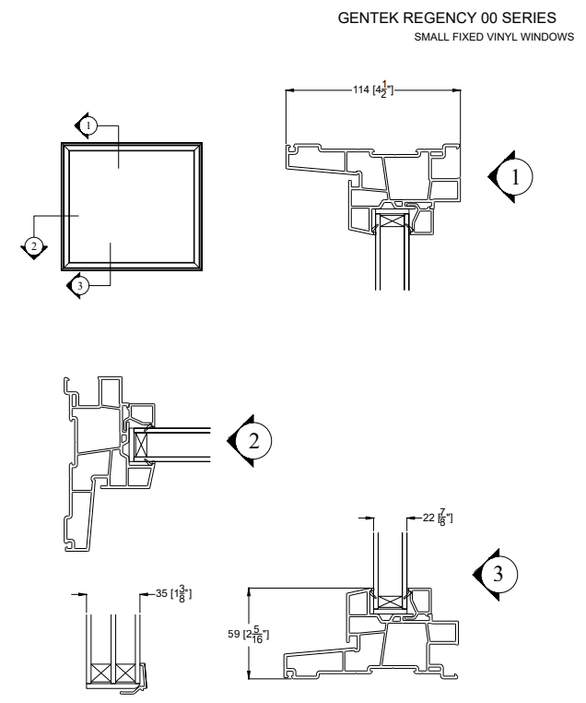

MULLING ASSEMBLY – COMPOSITE

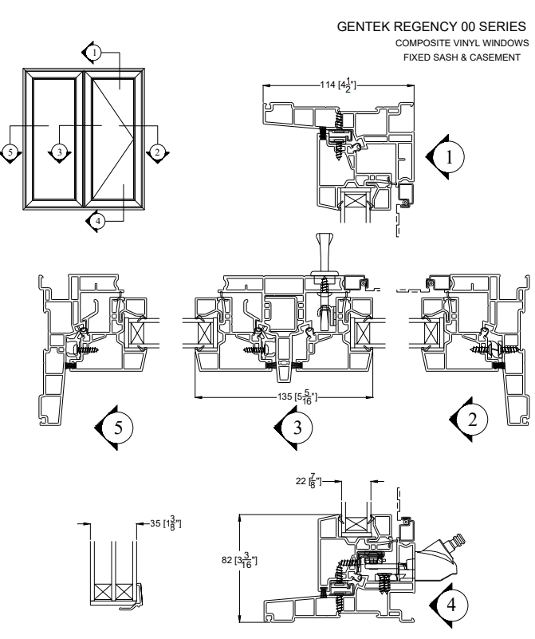

MULLING ASSEMBLY – COMBINATION

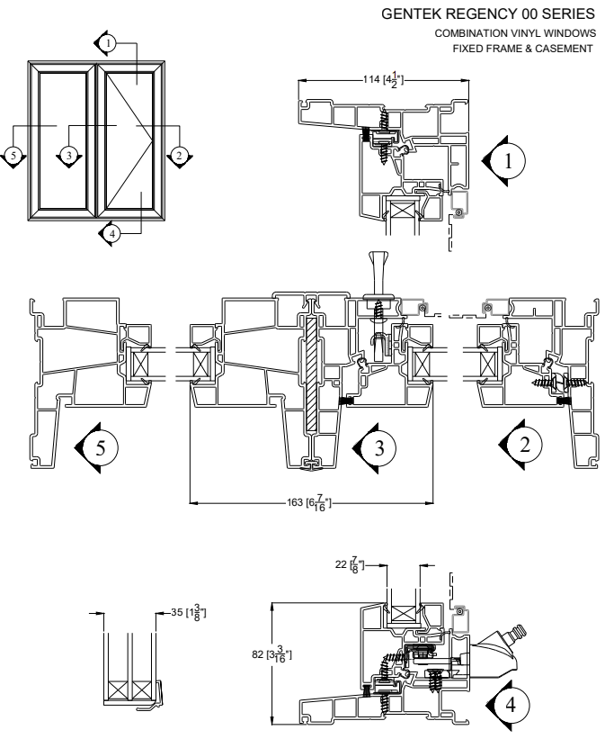

TEST REPORTS

